# CS 340 README Template

*Use this template to complete your README file. When completing the template, keep the headings as they are so that your document has a clear organization. Remove the italicized prompt text after you have completed each section for a polished final document.*

## About the Project/Project Title

This program allows the user to search the Austin Animal Center database using filters. These filters are water rescue, mountain or wilderness rescue, disaster rescue or individual tracking, and reset. The water rescue filter finds animals suitable for water rescue training. The mountain or wilderness rescue filter searches for animals suitable for mountain or wilderness rescue training. The disaster rescue or individual tracking filter searches for animals suitable for this type of training and the reset filter resets the search to all animal in the database. When a filter is choosing the table and pie chart change to the filter results and the geolocation chart shows the first animal found in the search.

## Motivation

The motivation for creating this program is to allow Grazioso Salvare to identify dogs for search and rescue training. The program will allow the user to search the database using filters to find dogs that are suitable for different type of training. This will help Grazioso Salvare to find animals for their training and help Austin Animal Center to find home for their animals.

## Getting Started

The Austin Animal Center database contents documentation of all the animals at the center. The aacuser account allows the user to read the documents on the Austin Animal Center database. When the program is running all of the animal’s information is put into the data table and all the different breeds are used to create the pie chart along with the first animal location from the data table is put on the geolocation chart. To change the filtering to see what animals are good for which training the user can use the radio buttons at the top of the table.

## Installation

To use this program MongoDB and Jupyter Notebook needs to be installed also files animal_shelter.py and ProjectTwoDashboard.ipynb need to be downloaded into the same directory. The reason MongoDB needs to be download is because Austin Animal Center database is located on MongoDB. Jupyter Notebook allows the user to run the files animal_shelter.py and ProjectTwoDashboard.ipynb.ipynb. The files allow the user to access the Austin Animal Center database and read the files into the dash allow the user an interface to the database.

## Usage

This program allows the user to access the Austin Animal Center database which holds documentation on the animals in the center. To run MongoDB the user must enter into the command prompt /usr/local/bin/mongod_ctl start-noauth. To use the program open Jupyter Notebook and opening the ProjectTwoDashboard.ipynb inside Jupyter Notebook. To access the Austin Animal Center database the user must enter username and password into the ProjectTwoDashboard.ipynb under username and password variables. Then the user can press run to use the filters the user can choose which one they want by clicking the radio button to the left of the filter they want to use.

### Code Example

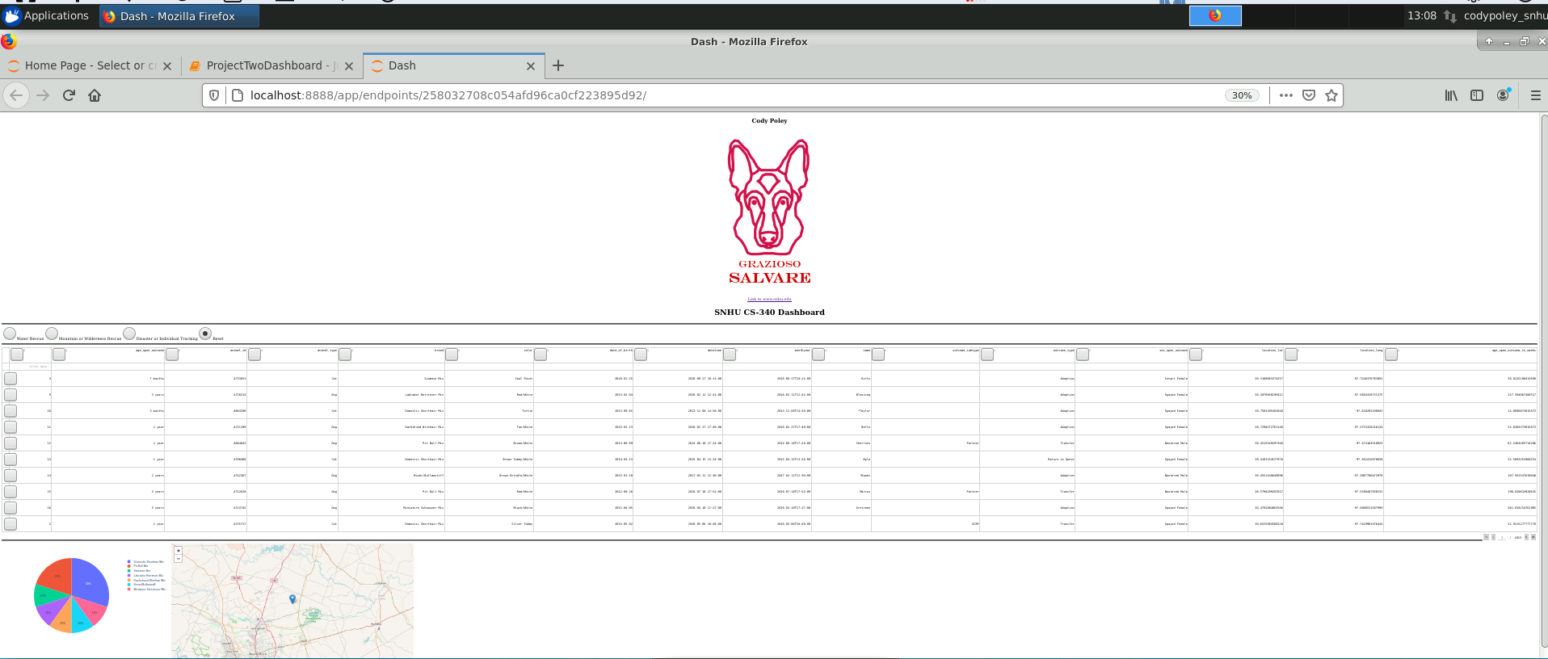

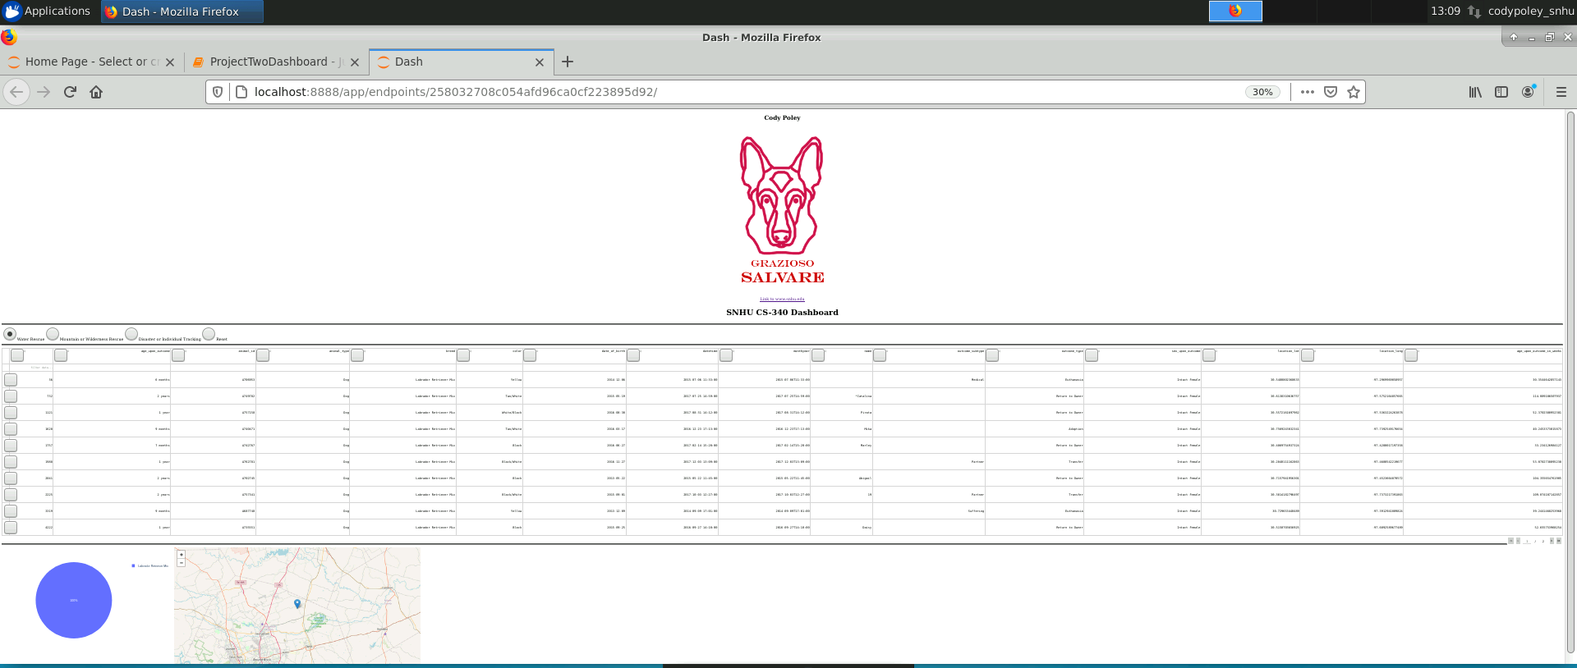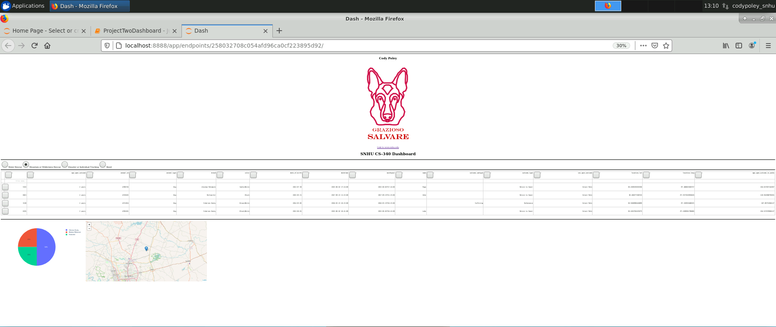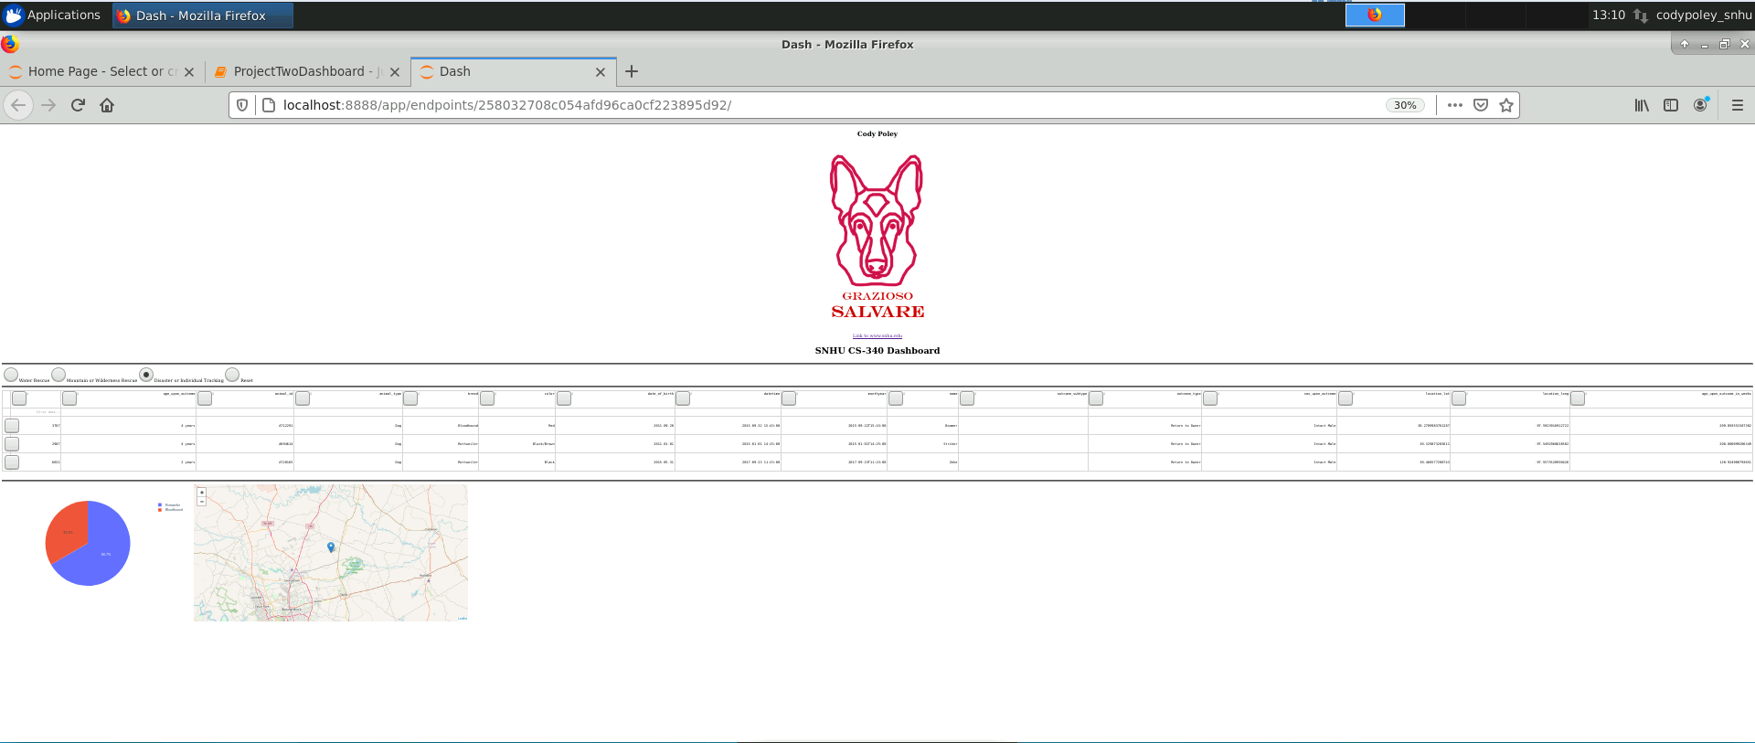

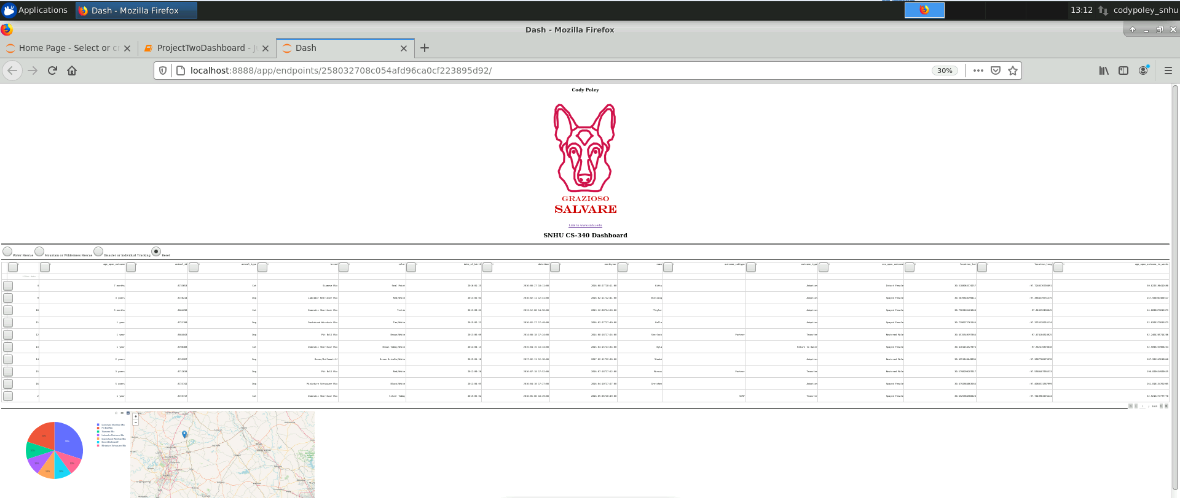

## Roadmap/Features (Optional)

*Provide an open issues list of proposed features (and known issues). If you have ideas for releases in the future, it is a good idea to list them in the README. What makes your project stand out?  
  
Note: This section is optional for the purposes of this assignment. If you choose not to fill out this section, remove it from your final README file.*

## Contact

Your name: